Ice Cream in a Bag
An easy step-by-step tutorial to make homemade ice cream in a bag!
Prep Time10 mins
Cook Time6 mins
Total Time16 mins
Course: Dessert
Cuisine: American
Keyword: homemade ice cream in a bag, ice cream in a bag, ice cream in a bag recipe
Servings: 2 people

Calories: 190kcal

Ingredients

SEE MORE

- 1 cup half and half
- 1.5 tsp vanilla extract
- 1 tbsp sugar
- ice
- 1/4 cup salt
- Ziploc bags 1 Small, 1 Large

Instructions
- Pour 1 cup of half and half into a small ziploc bag.
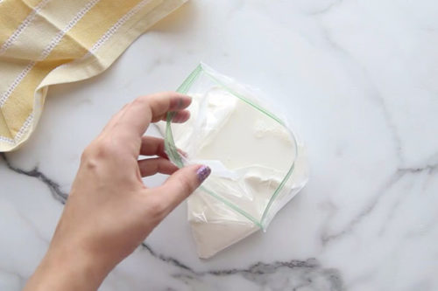

Sponsored by Canesten
Sponsored Video
Watch to learn more
- Add 1.5 teaspoons of vanilla extract and 1 tablespoon of sugar.
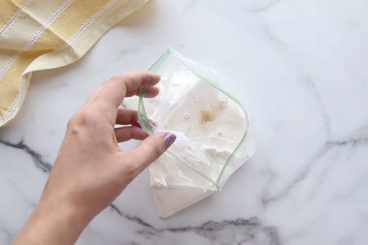
- Seal the bag firmly and get any excess air out.
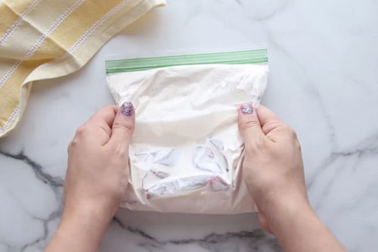
- In the larger ziploc bag, fill it about 1/2 way with ice. Add 1/4 cup of salt.
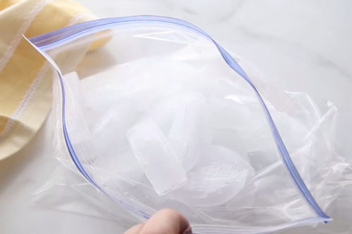
- Then add your small bag and fill with extra ice on top. Seal the large bag.
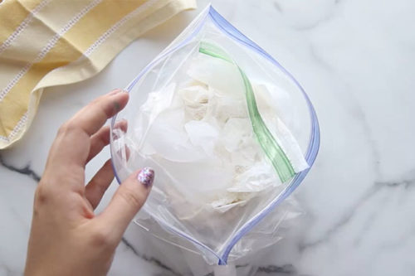
- Get gloves for shaking and shake for 6 minutes. *Gloves are needed since the salt makes the ice extra cold.
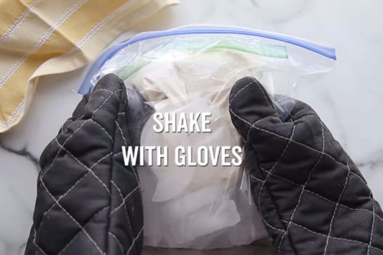
- Take the small bag out of the large bag and rinse the outside of the small bag with cold water. Make sure to rinse out the top part of the bag also (above the seal).
- Once done rinsing, carefully open the small bag to not get any remaining salt from the outside of the bag inside the bag.
- The ice cream will be a little icy looking to start. Use a spoon to mix it around and soften it up a bit. Scoop out and enjoy!
