S N O W U N I T

Learning Targets:
- I understand the science behind snow crystals
- I understand the importance of snow from the past to future
- I understand the basics of snow safety
- I can demonstrate a variety of winter activities safely and use the equipment properly

Purpose:
- This unit is to help students get excited, be more informed and learn new activities about winter.

Duration:
- 4 weeks

Outline:
- Snow science
- Snow importance
- Snow safety
- Snow fun

Final Project:
- Students will participate in the Amazing Race -Snow Edition.
- The race will highlight most of the things learned throughout this unit
- Students will be in teams
- This is a pass or fail performance task, though students will have to get it right before they move on and can ask their teammates for help

Outcome(s):

Math
- SS9.1

English
- CR9.1a
- CR9.5a

Science
- CE9.1
- CE9.3
- CE9.4

Social Studies
- RW9.3

Visual Arts
- CR9.2
- CR9.3
- CH9.3

Physical Education
- PE9.7
- PE9.9

Health
- USC9.2

23  Snow Science  Ice crystals - Ice Cream Making  Outside | 24  Snow Science  Snow electricity:  Can snow do this?  STEM | 25 | 26 -  Snow Science  Snow Analysis  What can snow tell us?  Snowshoe | 27-  Snow Science  Snow Analysis:  Understanding snow layers  Skiing
30  Snow Importance  Chasing Ice Documentary | 1  Snow Importance  Chasing Ice Documentary | 2 | 3  Snow Importance  Animals/trees  Snowshoe | 4  Snow Importance  People  Forts/snowball fight
7  Snow Safety  Winter survival | 8  Snow Safety  Winter Safety | 9 | 10  Snow Safety  Avalanche Safety | 11  Snow Safety  Person Tracker
14  Snow Fun  Design and create snow art | 15  Snow Fun  Banff Film Festival/snow vids  Design Video- pick activity, plan | 16  Snow Fun  Do activity, film | 17  Snow Fun  Edit films  Snow activity | 18  Snow Fun  Snow race  Watch films

Table of Contents Pages

Unit outline ---------------------------------------------------------------------------- 1
Outcomes ------------------------------------------------------------------------------ 2

Schedule ------------------------------------------------------------------------------- 3
Table of contents ------------------------------------------------------------------- 4

Snow Science
Snow Crystals ------------------------------------------------------------------------- 5- 10
Ice Cream ------------------------------------------------------------------------------ 11-14
Snow Electricity ----------------------------------------------------------------------- 15- 18 Snow Analysis (ratio) ---------------------------------------------------------------- 19- 21
Snow Analysis (layers) ------------------------------------------------------------- 22- 24

Snow Importance
Chasing Ice ----------------------------------------------------------------------------- 27-28
Animals/people ------------------------------------------------------------------------ 29
People ----------------------------------------------------------------------------------- 30

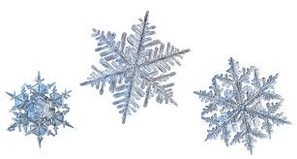
SNOW CRYSTALS

Learning Targets:
- I understand snow molecular structure
- I understand why snow crystals have 6 sides
- I understand freezing point depression

To be scientists we must develop scientific literacy (use science words). For this reason we will be calling snowflakes, snow crystals.

Purpose:
- Introduction to snow science. Developing an understanding of snow molecular structure, why snow crystals have six sides and its stages of development

Activity:
- Look at the diagram below. Gather an understanding of a water molecule
- Follow along with the videos. Gather as much information that you understand. We will answer the questions as a class.

Resources:
- https://www.youtube.com/watch?v=FwGH4gulLX4
- Consolidate knowledge- https://www.youtube.com/watch?v=fUot7XSX8uA

Beforehand
- Look up terms and write definitions
- Look at the diagrams below, write any questions or understandings you have on the side.

Snow Science Vocabulary:

Snow crystal-

Atom-

Molecule-

Proton-

Electron-

Charge-

Covalent bonds-

Repulsion-
Hydrogen bond-
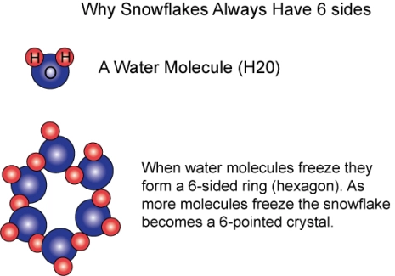
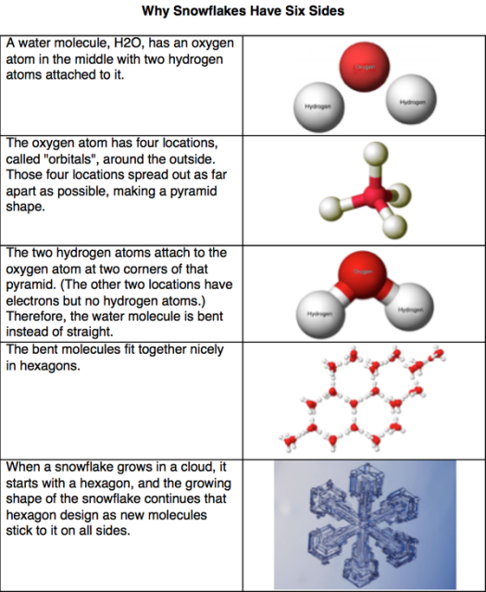

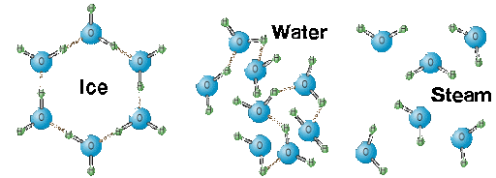

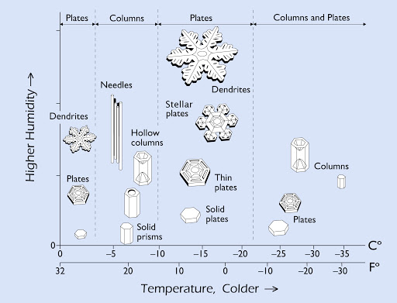

The Science of Snowflakes - Marusa Bradac

How does a snow crystal form?

What makes water? How many protons and electrons?

Water-

Protons-

Electrons-

Draw a picture of a water molecule.

How do water molecules attract each other? Draw a picture if you need.

Why is the angle in a water molecule important?

What affects a snow crystals shape?

What else did you find interesting about snow science?

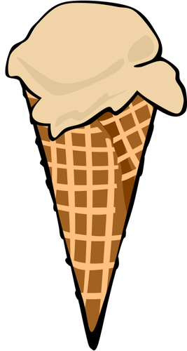
SNOW SCIENCE
ICE CREAM
Do you think snow is cold enough to make ice cream? Why or why not?

Ice Cream Ingredients:
- 2 zip lock bags - small and large
- ½ cup heavy cream
- 1 tablespoons of sugar
- ¼ teaspoon vanilla
- ½ large bag snow
- ½ cup of salt
- Mittens

Procedure:
- Put cream, vanilla, sugar in small bag, squish out air, close tightly
- In large bag, fill half way with snow and add the salt, squish are and close tightly
- Put on mitts and massage bags for five minutes. Be careful not to squeeze ingredients out of bag

What does the salt do to the snow to give you a delicious, wonderful, creamy, cold dessert?

Think about the molecular structure of snow. Make a hypothesis about what is happening to that structure when you add salt. Show your understanding. Draw a picture and label drawing.

What is freezing point depression?

Why do we need salt in the snow to make ice cream?

How do different molecules affect the molecules in water?

What is a natural example of freezing point depression?

Freezing Physics

by Gretchen Noyes-Hull
Not all water freezes at the same temperature. Most ocean water begins to freeze at about 2 degrees below zero (Celsius), and very salty water can remain liquid as cold as 20 degrees below! We can use the physics of freezing to our advantage—to make ice cream, for instance. The recipe for scientific ice cream is given below, but its flavor is enhanced by understanding how it is formed! Read on.
Temperature is a measure of how fast atoms or molecules are jiggling around. In order for things to freeze, the jiggling must slow down to allow strong bonds to form between them. Heat energy must be removed before substances can change from a liquid to a solid “phase.” Just how much heat is determined by the substance, and for water, how pure it is.
As heat is removed from water, the temperature drops, and the molecules begin to move more slowly. Bonds between them are made and broken again, until, at zero degrees, the jiggling has slowed enough so that more bonds are made than are broken. Water begins to solidify. If more heat is carried away, the process continues without any more change in temperature until all the molecules are linked together in a crystal “lattice.”
Molecules have more difficulty “grabbing arms” of their molecular neighbors when particles get in their way. If water is not pure, the temperature must be even lower for them to push the particles out of their way and form ice. This is known as “freezing point depression.” The more salt in seawater, the colder the temperature must be before ice will form.
Freezing-point depression is the whole point of ice cream–making! A lot of heat has to be removed for the water in cream to solidify. Because of all the particles it contains, the temperature must drop far below zero. The only way this can occur is to send the heat somewhere else!
Here's what happens. When ice cream is made the old-fashioned way, rock salt (big chunks of salt crystals) is mixed with ice. Only a little water melts before some of the dissolved salt lowers its freezing point. Now when the ice wants to melt, it can absorb lots of heat from the water to do it, and the water still will not freeze. (In the recipe you will try, the temperature of the water may decrease to almost minus 20 degrees C and still be liquid! Pretty cool!) The water is very much colder than the cream mixture. Because heat flows from hot things to cold things, the cream now loses its heat to the water and rapidly cools down.
Such a deal! It's a chain reaction of freezing-point depression. The freezing point of cream is depressed by the milk and sugar particles, and the freezing point of the water is depressed by the particles of salt. That's the point of ice cream. Enjoy!

SNOW ELECTRICITY
Learning Targets:
- I understand snow holds either a positive or negative charge
- I can comprehend how snow has a possibility for creating electricity

Purpose:
- Students will explore how electricity works by watching a video and answering questions. They will begin to understand the possibilities of using snow as an electrical source.

Activity:
- STEM:
  - Watch a video on electricity and fill out questions to gain background knowledge
  - Read notes on the water molecule. Does a water molecule have what it needs to produce electricity?
  - Practice creating an electrical current with a STEM activity.
  - Think about what snow would need to create electricity.

Resource:
- https://www.youtube.com/watch?v=mc979OhitAg (End at 3:09)
- Read article, https://bigthink.com/technology-innovation/electricity-from-snow?rebelltitem=2#rebelltitem2

Materials:
- Batteries
- Lightbulbs
- Copper wire
- Alligator clips
Basics of Electricity

Draw and label an atom.

What are atoms called that can pass electrons?

Example:

What are atoms called that cannot pass electrons?

Example:

What is a circuit? Draw an example.

Why are electrons important for creating electricity ?

Object | Insulator | Conductor | Light Intensity

Which object created the worst light intensity? Why do you think that is?

What object created the best light intensity? Why do you think that is?

Can snow create electricity?

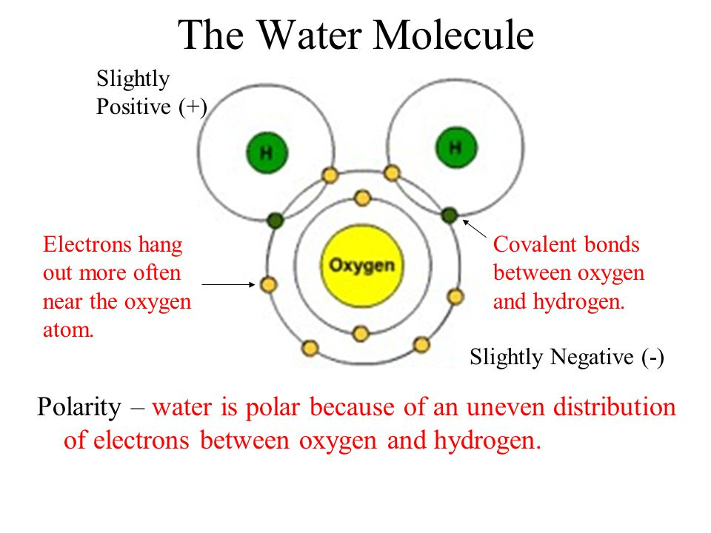
Does a water molecule have what it needs to create electricity? Why or why not?

What other questions do you have?

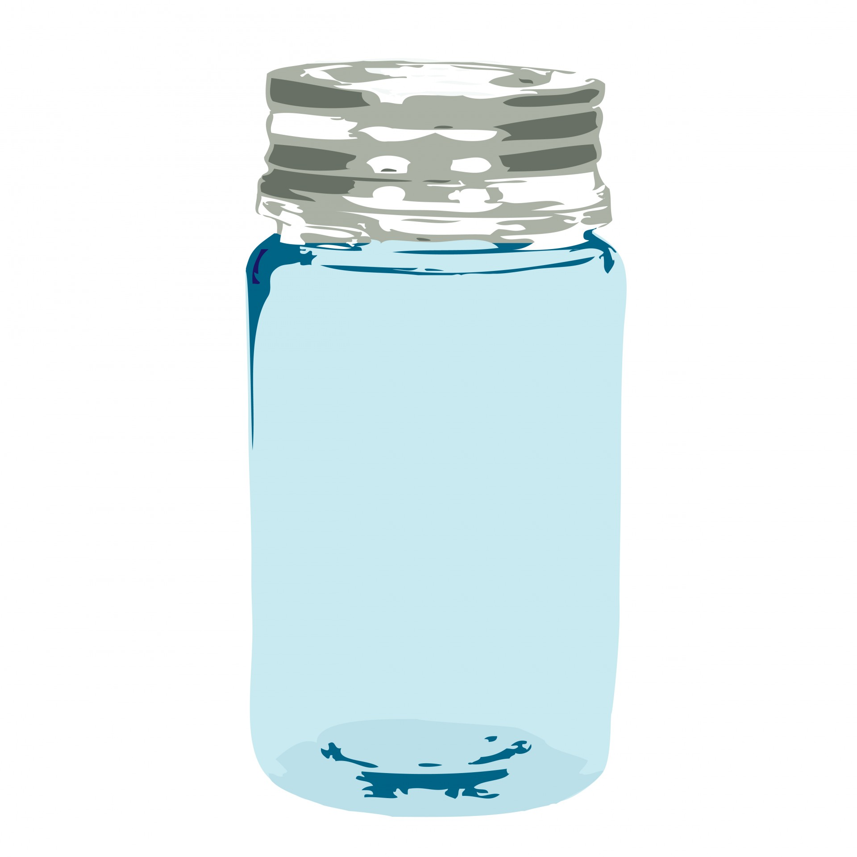
SNOW ANALYSIS

Learning targets:
- I understand snow ratio
- I can use scientific evidence to determine my hypothesis
- I can use snowshoes appropriately and safely

Purpose:
- To explore the ratio of snow to water in different designated areas. Will the snow that I collect in this area have the same amount of water as in a different area?

Activity:
- Students will be put into groups and be given a destination. They will explore the area using snowshoes. They will collect snow samples and give predictions to the snow ratio in each spot, that is how much water is in the snow. They will have to create a map showing where they have been and the spots they collected snow. Students will use the worksheet to guide their experiment.

Materials
- Jars - Four designates roles:
- Markers, pencil - snow collector
- Worksheet - data recorder
- Map -students create - navigator
- Snowshoes - snow melter
- Winter gear

Group members:

Area 1
Observations
(snow texture, appearance, weight, placement-under a tree, open area, etc. Be specific)

Questions
(Has anything disrupted the snow? Has it melted?)

Hypothesis
(Due to this, we think the ratio will be this)

Method
(How are you measuring your results? What units are you using?)

Results
(snow to water ratio)

Area 2
Observations
(snow texture, appearance, weight, placement-under a tree, open area, etc. Be specific)

Questions
(Has anything disrupted the snow? Has it melted?)

Hypothesis
(Due to this, we think the ratio will be this)

Method
(How are you measuring your results? What units are you using?)

Results
(snow to water ratio)

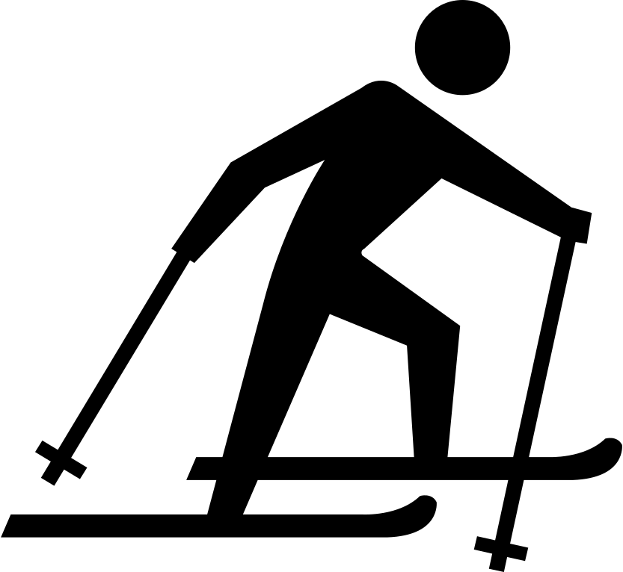
SNOW
ANALYSIS
Learning Targets:
- I understand how snow can tell us about the past
- I understand how snow can tell us about the future
- I can cross-country ski appropriately and safely

Purpose:
- The students will use their learning from this unit to try and use their snow sense to predict and determine future and past events. They will cross-country ski around an area and examine snow layers. In the layers they will be classifying the three types of snowpack, describing its appearance and texture and creating a timeline of snowfalls.

Activity:
- In groups the students will cross-country ski to different areas. They will mark on their map their route and where they collected data. By looking at the different snow layers they will try to determine the previous snowfalls, if any other particles were in the air during those snowfalls and label the layers by the three classifications of snowpack. They will record their data on their worksheet.

Materials
- Cross-country skis
- Winter gear
- Writing utensils, clip board
- Data collection sheet
- Map
- Shovel
- Designated roles decided by the group

Classification sheet:

Three types of layers:
- Thick, thin
- Hard, soft
- Strong, weak

Number of layers are visible:
- Determines snow fall, weather change

Snow appearance:
- Other matter visible- colour
- Fluffy, compacked, etc
- Wet, dry

What else is important?

How to:
- Use your map, mark route and area of data collection
- Find an area with a large mound of snow
- Before you begin fill out the worksheet
- Cut into the snow with your shovel/hand (like you are carving a wall) to expose the snow layers
- Draw a picture of the snow layers in diagram on worksheet
- Label the layers with the classifications above
- Once snow layers have been collected conduct a snow ratio test
- Fill in the remaining worksheet about the findings
- Answer the questions

Group members:
Area:
Diagram
(number of layers, the type of snow, colour, texture, appearance)

Include:
Measurements
Observation

What can you infer about previous snowfalls?

How much?
Type of snow?
Weather change?
Particles?
Hypothesis
(snow ratio)

Snow Ratio
Environment

Diagram
(number of layers, the type of snow, colour, texture, appearance)

Include:
Measurements
Observation

What can you infer about previous snowfalls?

How much?
Type of snow?
Weather change?
Particles?

Hypothesis
(snow ratio)

Snow Ratio
Environment

SNOW IMPORTANCE
Learning Targets:
- I can draw the water cycle and know why snow is important
- I know what climate change is and can give examples of its effects

Purpose:
- This is to bring awareness to the climate changes that are happening and how ice is a visual indicator. The students will be able to show examples of climate change and determine how snow and ice is being affected.

Activity:
- The class will be split into four groups, two will draw the water cycle, the other two will draw things which will be in the water, ex// water droplets, salt, dust, pollution, fish, trash, chemicals, etc. We will come together as a class and discuss. Why is snow important to the water cycle?
- Watch a video on climate change. Students will fill out the worksheet.
- Class discussion

Resources:
- http://www.documentarymania.com/player.php?title=Chasing%20Ice

Materials:
- Large paper, pencil, colouring utensils, tape
- Worksheet

Examples: | Evidence:
Climate Change definition:
Questions: | Affecting our way of life:

SNOW IMPORTANCE
Animals and Trees
Learning Targets:
- I can identify animals and plants that are in my neighbourhood
- I understand the importance of plants for animals during the winter months

Purpose:
- Have the students explore their neighbourhood and figure out the plants and animals that live in the area.

Activity:
- By snowshoe, students will evaluate signs of animal activity in their neighbourhood. They will be able to identify the name of trees and animals and hopefully be able to feed the chickadees. Students will research beforehand plants and animals in the area and share with the class.

Materials:
- Snowshoes
- Winter gear
- Bird seed
- Local animal/plant guide developed by students

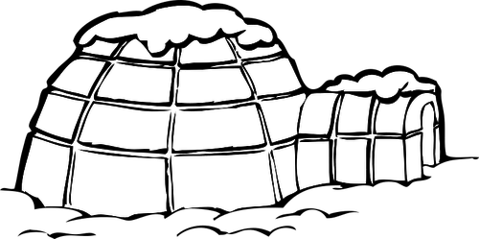
SNOW
IMPORTANCE

Learning Targets:
- I know different methods people around the world use for snow homes
- I can make a snow fort safely and with an understanding of the risks involved
- I can have a snowball fight while following the classroom rules

Purpose:
- For the students to learn how people who live in cold climates utilize snow for shelter. They will understand how snow works as an insulator and the benefits when living in cold climates.

Activity:
- In groups students will build a snow fort for use in the snowball fight. Groups will develop a plan for their structure beforehand with reference to the snow structures discussed during the lesson. Once the allotted time for building is up students will participate in a snowball fight. The group who has the most members left on their side with their structure still standing will be declared the winner.

Materials:
- Winter gear
- Area with snow
- paper , pencil - to plan structure

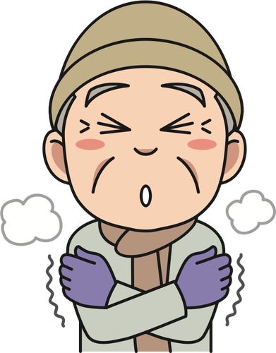
SNOW SAFETY

Learning Targets:
- I know what happens to the body when it is hypothermic
- I know how to prevent and treat hypothermia
- I understand ways to protect myself from the cold if I am stuck in the wilderness

Purpose:
- Students will research and present on their specific topic. They will teach each other how to stay safe from the cold, prevent and treat hypothermia and understand what happens to the body when it has hypothermia

Activity:
- Jig-saw- students will be split up into four groups to answer these questions.
  - What is hypothermia and how does it affect the body?
  - What are ways to prevent hypothermia?
  - What are ways to treat hypothermia?
  - If stranded outside in the cold what are the necessary survival skills?

Materials:
- Computers
- Large paper, markers, sticky notes, tape glue, pencil

SNOW SAFETY
Learning Targets:
- I know how to stay warm in the winter with limited supplies
- I understand what happens to my body during hypothermia
- I know how to help myself and others if they are hypothermic

Purpose:
- The students will demonstrate their understanding of how to stay safe if they are stranded in the snow and how to prevent and treat hypothermia.

Activity:
- Students will be given scenarios in which they will have to use what they have learned to stay “alive”. They will be put into groups and be given a snow kit. This kit will consist of random things which could be found on a person stuck outside. This will be a timed scenario based on the body's resistance to cold and onset of hypothermia.

Materials:
- Winter gear
- Blanket(s)
- Fire building materials - paper, matches
- Cup
- TBD - depending on student brainstorming
- Students will use the information they gathered from previous lesson on snow safety

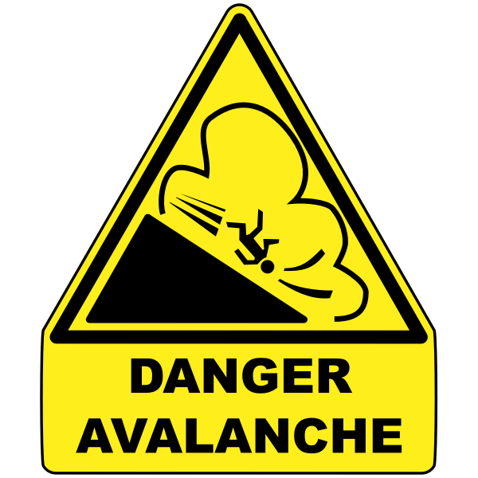
SNOW SAFETY

Learning Targets:
- I understand what an avalanche is and the conditions that make them more probable
- I can give an example of an avalanche and what an avalanche is not
- I understand the basics of avalanche search and rescue

Purpose:
- Students will be able to comprehend the dangers of snow but also the science behind why these natural disasters occur. Students will use their understanding of the search and rescue

Activity:
- Students will watch a video on avalanches and the search and rescue techniques
- They will fill out their worksheet. This information will be used for the next lesson

Materials:
- Writing utensil
- Worksheet

Resources:
- News report- https://www.youtube.com/watch?v=bs1dI6mtnaM
- https://www.youtube.com/watch?v=5sf7bj5dCJs

Name:
Examples:  What an avalanche is not: | Search and rescue:
Avalanche definition:
Questions: | Snow conditions:

SNOW SAFETY

Learning Targets:
- I can treat for hypothermia
- I have skills to perform a search and rescue
- I can participate in the game and be a team player

Purpose:
- Students will use the information gained during this unit to participate in a rendition of capture the flag. They will use their knowledge of survival and search and rescue to treat the “hurt” flags.

Activity:
- Students will play a game of capturing the flag. There will be three levels of flags and obstacles throughout the game. We have discussed avalanches, hypothermia and search and rescue. Students will use their knowledge to capture the hurt flags and treat them before the other team does.

Materials:
- Outdoor gear
- 6 flags- 3 pairs of different colours

NEED TO MAKE RULES

SNOW ART

Learning Targets:
- I understand the properties of a circle
- I can design and create snow art with the properties of a circle
- I can work with my group in a collaborative way

Purpose:
- Students will understand the properties of a circle and how math can be used to create snow “crop circles”. This project will be created outside and at a large scale.
- Simon Beck, artist who creates snow art with his feet.
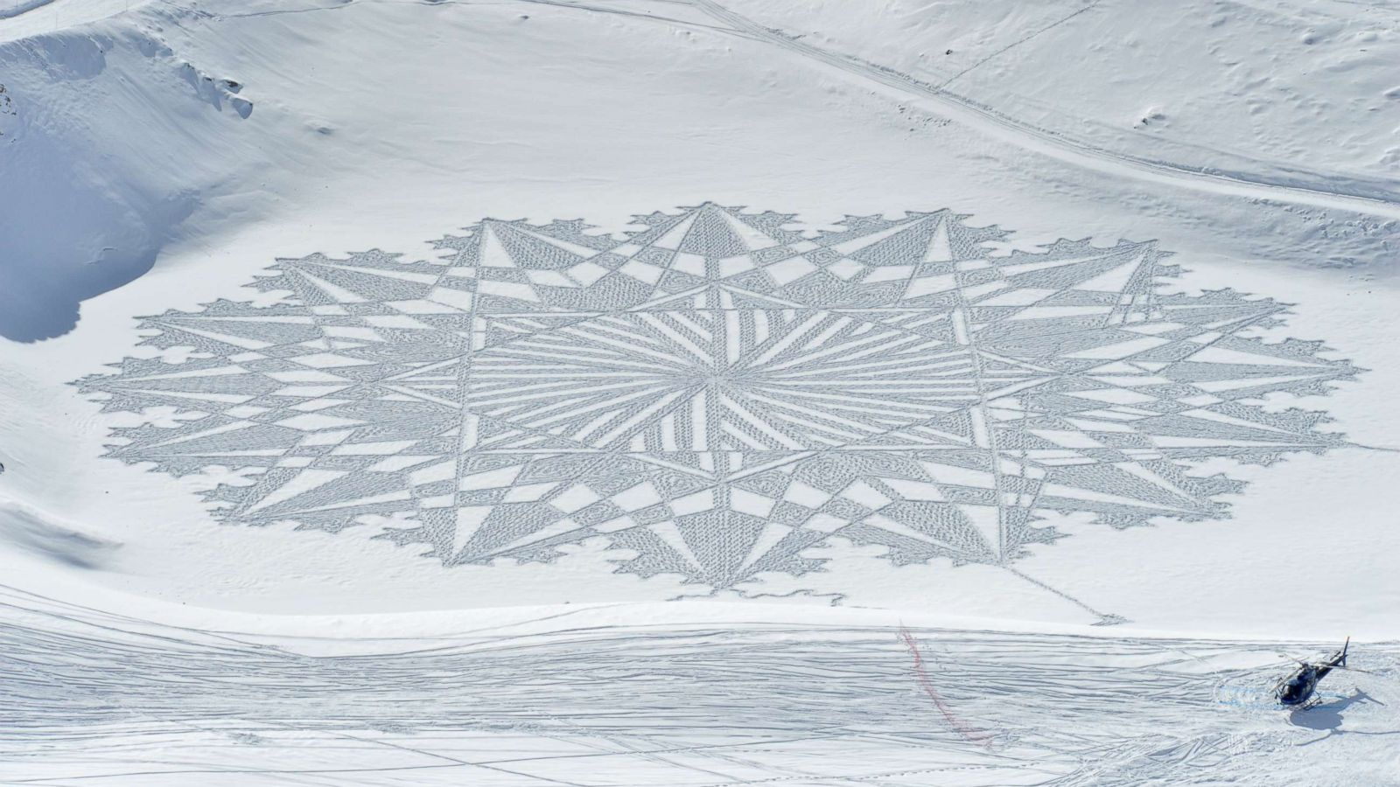

Activity:
- Introduction lesson: students will brainstorm the properties of a circle and how using a radius they can create symmetrical designs throughout, like a protractor.
- Students will be put into groups. They will have to create a design together along with a list of materials and measurements for their project. The students will also be asked to label the parts of their design using math literacy, radius, circumference, etc.

Materials:
- TBD by students
- Winter gear

Outcome(s):
Math
SS9.1
Demonstrate understanding of circle properties including:
- perpendicular line segments from the centre of a circle to a chord bisect the chord
- inscribed angles subtended by the same arc have the same measure
- the measure of a central angle is twice the measure of an inscribed angle subtending the same arc
- tangents to a circle are perpendicular to the radius ending at the point of tangency
Visual Art
CR9.2
Investigate and identify ways that today's arts expressions can inspire change.

SNOW FUN
Action Shots

Learning Targets:
- I can create a video that promotes snow safety and enjoyment
- I can edit the video to be expressive and visually artistic for my viewers
- I can work with my group in a collaborative way

Purpose:
- The students will engage in digit visual and auditory art. They will create a video that promotes something they like to do in the winter time

Activity
- students will create a video of something they like to do outside in the winter. They will work in groups, assign tasks and jobs to finish in a timely fashion. All videos shall meet the criteria below.

Criteria:
- Must showcase an outdoor snow activity.
- All members of group must be involved in the production
- Video has a 5 minute minimum and a 10 minute maximum
- Must have music
- All visuals and audios must be school appropriate

Outcome(s):
- Art- CR9.3, CH9.3
- Physical education- PE9.7, PE9.9

